**PART-A (About 2-3 Pages)**

# Format for Micro-Project Proposal For 1st to 4th Semester

**Title of Micro Project: Create cloud kitchen** **management Database System .**

**1.0 Brief Introduction: (Importance of the Project, in about 4 to 5 sentences)**

A cloud kitchen management database system is a complex database system that is designed to handle the day-to-day operations of a cloud kitchen. It must be able to efficiently manage orders, inventory, staff, and finances.

The system will consist of multiple tables, including an orders table, an inventory table, a staff table, and a finances table. Each of these tables will contain relevant information about the kitchen's operations, including orders, inventory levels, staff schedules, and financial transactions.

The system will also include several stored procedures and functions that will allow users to interact with the database. For example, there will be a stored procedure that allows users to place orders, and another one that updates inventory levels when an order is fulfilled.

Security is a critical consideration for this database system, as it will be handling sensitive information about the kitchen's operations. Therefore, the system will be designed with robust security measures, including user authentication and authorization, encryption of sensitive data, and regular backups.

Overall, a cloud kitchen management database system must be highly reliable, efficient, and secure in order to effectively manage the complex operations of a cloud kitchen.

We have implemented these concepts by the use of queries. We have used topics like SQL concepts, Advanced SQL concepts, PL SQL in This project.

**2.0 Aim of the Micro Project (in about 4 to 5 sentences)**

The Aim of this project to develop a Cloud kitchen management Database System .

**3.0 Action Plan (Sequence and time required for major activities for 8 weeks)**

|  |  |  |  |  |
| --- | --- | --- | --- | --- |
| **Sr.**  **No.** | **Details of Activity** | **Planned**  **Start Date** | **Planned**  **Finish Date** | **Name of Responsible Team Members** |
| 1 | ER Diagram | 25/05/2021 | 25/05/2021 | Jagganath Kumbhar |
| 2 | Teams Table, Players Table | 27/05/2021 | 27/05/2021 | Harshit chuhan |
| 3 | Matches Table, Goals Scored Table | 27/05/2021 | 27/05/2021 | Shaikh muhammed |
| 4 | Clean Sheets Kept Table, Standings  Table, Other Queries | 27/05/2021 | 27/05/2021 | Harshit Chauhan |
| 5 | PPT | 04/06/2021 | 04/06/2021 |  |

**4.0 Resources Required (Such as raw material, some machining facility, software etc.)**

|  |  |  |  |  |
| --- | --- | --- | --- | --- |
| **Sr.**  **No.** | **Name of Resource/Material** | **Specifications** | **Qty** | **Remarks** |
| 1 | Laptop OS Windows 10 | 1 TB, 8GB RAM | 1 |  |
| 2 | Oracle LiveSql | Database product | 1 |  |
| 3 | Internet | Broadband | 100 mbps |  |

**PART-B (Outcomes after Execution and Format for Micro-Project Report, About 6-10 Pages)**

**For 1st to 4th Semester**

**Title of Micro Project: Create University database**

**1.0 Brief Description: (Importance of the project, in about 100 to 200 words)**

A cloud kitchen management database system is a complex database system that is designed to handle the day-to-day operations of a cloud kitchen. It must be able to efficiently manage orders, inventory, staff, and finances.

The system will consist of multiple tables, including an orders table, an inventory table, a staff table, and a finances table. Each of these tables will contain relevant information about the kitchen's operations, including orders, inventory levels, staff schedules, and financial transactions.

The system will also include several stored procedures and functions that will allow users to interact with the database. For example, there will be a stored procedure that allows users to place orders, and another one that updates inventory levels when an order is fulfilled.

Security is a critical consideration for this database system, as it will be handling sensitive information about the kitchen's operations. Therefore, the system will be designed with robust security measures, including user authentication and authorization, encryption of sensitive data, and regular backups.

Overall, a cloud kitchen management database system must be highly reliable, efficient, and secure in order to effectively manage the complex operations of a cloud kitchen.We have implemented these concepts by the use of queries. We have used topics like SQL concepts, Advanced SQL concepts, PL SQL in This project.

**2.0 Aim of Micro Project: (in about 100 to 200 words)**

The Aim of this project to develop a Cloud kitchen management Database System .

**3.0 Course Outcomes Integrated (Add to the earlier list if more CO’s are addressed)**

**C01, C02, C03, CO4**

**4.0 Actual Procedure followed**

(Write stepwise the work done, including team member did what work and how the data was analyzed, if any)

|  |  |  |  |  |
| --- | --- | --- | --- | --- |
| **Sr.**  **No.** | **Details of Activity** | **Planned**  **Start Date** | **Planned**  **Finish Date** | **Name of Responsible Team Members** |
| 1 | ER Diagram | 25/05/2021 | 25/05/2021 | Shaikh muhammed |
| 2 | Teams Table, Players Table | 27/05/2021 | 27/05/2021 | Harshit chauhan |
| 3 | Matches Table, Goals Scored Table | 27/05/2021 | 27/05/2021 | Jagganath kumbhar |
| 4 | Clean Sheets Kept Table, Standings  Table, Other Queries | 27/05/2021 | 27/05/2021 |  |
| 5 | PPT | 04/06/2021 | 04/06/2021 |  |

## 5.0 Action Plan ( Sequence and time required for major activities for 8 weeks)

|  |  |  |  |  |
| --- | --- | --- | --- | --- |
| **Sr.**  **No.** | **Details of Activity** | **Planned**  **Start Date** | **Planned**  **Finish Date** | **Name of Responsible Team Members** |
| 1 | ER Diagram | 25/05/2021 | 25/05/2021 | Shaikhmuhammed |
| 2 | Teams Table, Players Table | 27/05/2021 | 27/05/2021 | Jagganath kumbhar |
| 3 | Matches Table, Goals Scored Table | 27/05/2021 | 27/05/2021 | Harshit chauhan |
| 4 | Clean Sheets Kept Table, Standings  Table, Other Queries | 27/05/2021 | 27/05/2021 |  |
| 5 | PPT | 04/06/2021 | 04/06/2021 |  |

**6.0 Actual Resources Used: (Mention the actual resources used)**

|  |  |  |  |  |
| --- | --- | --- | --- | --- |
| **Sr.**  **No.** | **Name of Resource/Material** | **Specifications** | **Qty** | **Remarks** |
| 1 | Laptop OS Windows 10 | 1 TB, 8GB RAM | 1 |  |
| 2 | Oracle LiveSql | Database product | 1 |  |
| 3 | Internet | Broadband | 100 mbps |  |

**7.0 Output of the Micro Project**

## (Drawings of the prototype, drawings of survey, Presentation of collected data, Findings etc)

**CREATING SEQUENCE:-**

**Tables:**

**Creating Table:**

**Inserting Data:**

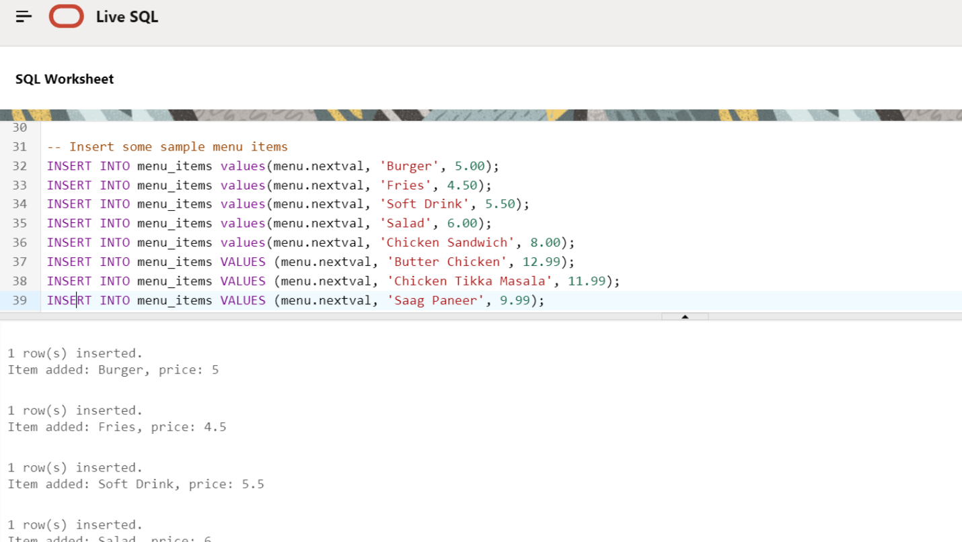

**Creating Table:** **create table FOR ORDER:-**

**Inserting Data:**

**Creating Table:**

**create table FOR ORDER ITEMS**

**

**UPDATE:-**

**UPDATE MENU ITEMS:-**

**\*QUERIES OF ALL THE ORDER WITH THEIR ITEMS AND TOTAL PRICE:-**

**\*CALCULATING THE PRICE *QUALITY WITH JOIN.**

**\*__VIEW SECTION(ITEMS_NAMEAND ITS PRICE)__________________________________________**

**Synonym for Clean Sheets Kept:** **creating synonym:-**

**View 1:**

CREATE VIEW:-

7.0 Skill Developed/Learning out of this Micro Project

During the projects running, we were able to develop many skills. We developed skills like Time Management, where we scheduled meetings online to discuss and develop the projects. We developed teamwork skills as we communicated online. We also learned Communication skills, along with digital skills as during these tough times we were still able to complete the project from home using video calling software.

ER DIAGRAM :- 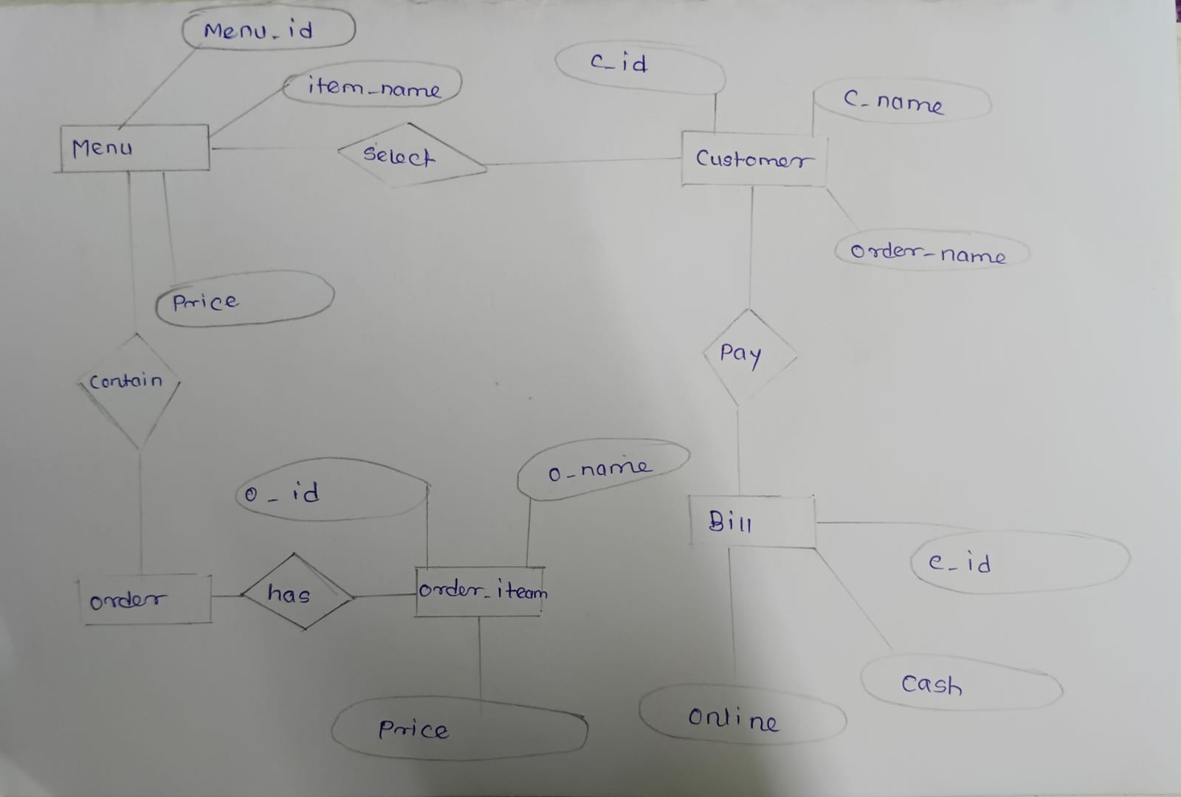

**Name of Student: SHAIKH MUHAMMED**

**Name of Program: Database Management Semester: 4**

**Course Title: Information Technology Code: 22416**

**Title of the Micro Project: : Create cloud kitchen management Database System .**

# Micro Project Evaluation Sheet

|  |  |  |  |  |
| --- | --- | --- | --- | --- |
| **Process Assessment** | **Product Assessment** |  | **Total Marks 10** | |
| **Part-A Project**  **Proposal**  **(Mark-2)** | **Project**  **Methodology**  **(Mark-2)** | **Part-B**  **Project Report/**  **Working Model**  **(Marks-2)** | **Individual**  **Presentation/**  **Viva**  **(Marks-4)** |  |
|  |  |  |  |  |

**Note: Every course teacher is expected to assign marks for group evolution in first 3 columns and individual in 4th columns for each group of students as per rubrics.**

**Comments/Suggestions about team work/leadership/inter-personal communication (if any)**

**----------------------------------------------------------------------------------------------------------------------------------------------------------------------------------------------------------------------------------------**

**Any other Comments:**

**---------------------------------------------------------------------------------------------------------------------**

**---------------------------------------------------------------------------------------------------------------------**

**Name and Designation of Faculty Members**

**Signature:**

**Name of Student: Jaganath Kumbhar**

**Name of Program: Database Management Semester: 4**

**Course Title: Information Technology Code: 22416**

**Title of the Micro Project: : Create cloud kitchen management Database System .**

# Micro Project Evaluation Sheet

|  |  |  |  |  |
| --- | --- | --- | --- | --- |
| **Process Assessment** | **Product Assessment** |  | **Total Marks 10** | |
| **Part-A Project**  **Proposal**  **(Mark-2)** | **Project**  **Methodology**  **(Mark-2)** | **Part-B**  **Project Report/**  **Working Model**  **(Marks-2)** | **Individual**  **Presentation/**  **Viva**  **(Marks-4)** |  |
|  |  |  |  |  |

**Note: Every course teacher is expected to assign marks for group evolution in first 3 columns and individual in 4th columns for each group of students as per rubrics.**

**Comments/Suggestions about team work/leadership/inter-personal communication (if any)**

**----------------------------------------------------------------------------------------------------------------------------------------------------------------------------------------------------------------------------------------**

**Any other Comments:**

**---------------------------------------------------------------------------------------------------------------------**

**---------------------------------------------------------------------------------------------------------------------**

**Name and Designation of Faculty Members**

**Signature:**

**Name of Student: Harshit Chauhan**

**Name of Program: Database Management Semester: 4**

**Course Title: Information Technology Code: 22416**

**Title of the Micro Project: : Create cloud kitchen management Database System .**

# Micro Project Evaluation Sheet

|  |  |  |  |  |
| --- | --- | --- | --- | --- |
| **Process Assessment** | **Product Assessment** |  | **Total Marks 10** | |
| **Part-A Project**  **Proposal**  **(Mark-2)** | **Project**  **Methodology**  **(Mark-2)** | **Part-B**  **Project Report/**  **Working Model**  **(Marks-2)** | **Individual**  **Presentation/**  **Viva**  **(Marks-4)** |  |
|  |  |  |  |  |

**Note: Every course teacher is expected to assign marks for group evolution in first 3 columns and individual in 4th columns for each group of students as per rubrics.**

**Comments/Suggestions about team work/leadership/inter-personal communication (if any)**

**----------------------------------------------------------------------------------------------------------------------------------------------------------------------------------------------------------------------------------------**

**Any other Comments:**

**---------------------------------------------------------------------------------------------------------------------**

**---------------------------------------------------------------------------------------------------------------------**

**Name and Designation of Faculty Members**

**Signature:**